Dashboard Feedback & Recommendations
Global Messaging Updates
- Remove: “Transform Patient Care…”
Replace with:
“Intelligent preparation for a high-quality care experience.”
- Remove:
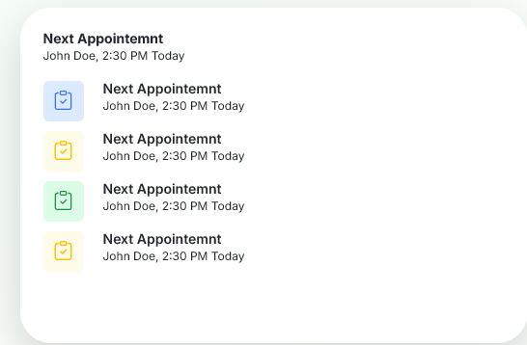
(The demo itself should convey this.)
Section: For Patients / For Physicians (Clarification)
Recommendation: Reframe this section to clearly target physicians not patients.
- Add
“Patient Centered, Physician Driven.” Remove Careflow….etc…
Suggestions:
“Advanced AI technology that helps physicians and care teams stay one step ahead—reducing clerical and documentation burden so more time can be spent on patient-centered care.”
This reframes the “why” clearly for physicians while preserving patient benefit.
Compliance & Risk Language Removals
- Remove: Real-time patient monitoring
Physicians are not providing 24/7 care through the app; this poses legal/compliance risk.
- Avoid using: Assessment
  - Assessments are conducted by physicians after information is gathered.
- Avoid stating: AI “makes recommendations”
  - Physicians have expressed concern about AI encroaching on clinical expertise.
Approved, physician-aligned language:
- Pre-visit symptom questionnaire
- Ambient AI listening during patient encounters to enable patient-focused visits
- AI-captured visit summary to support documentation, ready for physician review and signature
- After-visit summary provided to patients
- Task Reminder Notes
How It Works (Reorganized Flow)
- Clinical team sends a pre-visit questionnaire based on the reason for appointment
- Physician reviews patient-submitted information ahead of the visit
- Visit begins with ambient AI listening enabled
- Visit completed: AI summarizes the encounter, ready for physician review and signature
- After-visit summary is shared with the patient
Why Physicians Choose Medigenie
(Rename from “Why Healthcare Teams Choose Us”)
Initial focus is on individual physicians, not clinics or practices. Group/practice expansion can be positioned as a future phase.
Suggested content:
- Fast Implementation
Get up and running in hours with a streamlined onboarding process.
- Reduced Documentation Burden
Spend less time charting and more time caring for patients.
- Increased Productivity & Revenue
Decreased documentation time allows clinicians to accommodate additional patient encounters.
- Improved Work–Life Balance
Less after-hours charting supports clinician well-being.
- Multilingual Support
Available in multiple languages, with more to come.
Remove from This section
- 24/7 support (remove for now)
Pricing (Early-Stage Alignment)
- Pricing should be per clinician subscriber
- Final pricing to be adjusted based on market benchmarks
- Include Military / Veteran discount
Future of Healthcare Section
Remove the following (out of scope for MVP):
- Predictive analytics
- Real-time monitoring
- Computer vision

